WELCOME TO

TAIHAPE AREA SCHOOL

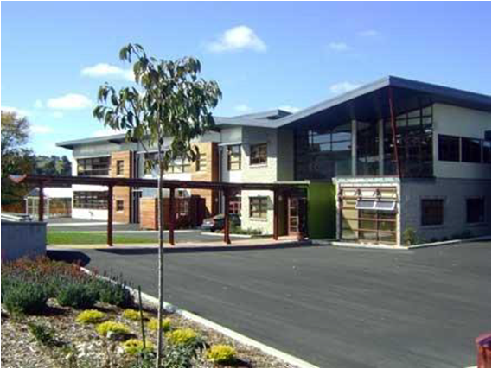

We trust that your child will enjoy their education at our school. This booklet is designed to give parents and whanau some important information about the school, and we suggest you keep it in a safe place for reference. Of course there are many points that cannot be covered in such a booklet, and we are always pleased to answer any further queries that may arise.

Contacts

Phone: (06) 388 0130

Website: www.tas.school.nz

Principal: Richard McMillan rmcmillan@tas.school.nz

Office Manager: Cathy Gregory cgregory@tas.school.nz

Deputy Principal Barb Wallis bwallis@tas.school.nz

Deputy Principal Andy Lincoln alincoln@tas.school.nz

Junior Leader Leah Collings lcollings@tas.school.nz
Mission Statement | “Taihape Area School - Leading Me to Lead My Learning”
Vision | Our young people will be….  Confident  - Positive in their own identity;  - Motivated and reliable;  - Entrepreneurial;  - Enterprising;  - Resilient.  Connected  - Able to relate well to others;  - Effective users of communication tools.  Actively Involved  - Participants in a range of life contexts;  - Contributors to the wellbeing of New Zealand – social, economic, and environmental.  Lifelong Learners  - Literate and numerate;  - Critical and creative thinkers;  - Active seekers, users, and creators of knowledge;  - Informed decision makers.
Values | Four Te Ao Maori values, which align with the NZ Curriculums Key Competencies, are being developed school-wide. They are competencies which empower our 21st Century Learners. These are the values of Manaakitanga, Rangatiratanga, Whanaungatanga and Wairuatanga.
Principles | At Taihape Area School we walk the beliefs of our Learning Community by demonstrating the value of: -  - Rangatiratanga, Wairuatanga, Manaakitanaga, and Whanaungatanga;  - A caring and sharing family atmosphere;  - Recognizing everyone as a learner;  - Emphasizing numeracy and literacy programmes;  - A welcoming and inviting school environment;  - Implementing the PB4L (Positive Behaviour for Learning) programme to ensure a positive physical and emotional context for learning;  - A balance of academic, sporting, and cultural learning activities, including regular EOTC experiences for all students;  - Acknowledging success and promoting high expectations in all areas;  - A genuine partnership with our community;  - A passionate, committed and caring staff;  - Celebrating the bicultural identity of our school community, and developing students who are culturally confident;  - Effective management systems to support learning.
Māori Dimensions and Cultural Diversity | The Board takes all reasonable steps to provide instruction in Tikanga Maori (Maori culture) and Te Reo Maori (Maori language).When developing policies and practices for the school every endeavour will be made to reflect New Zealand Cultural diversity and the unique position of Maori culture. Taihape Area School offers optional Te Reo classes in years 7-13. Various Te Reo opportunities are available through whole day options.  The board will respond to any request for instruction in Te Reo Maori by:  - Advising the parent/s of the current level of Te Reo and Tikanga Maori available at the school;  - Offering to explore possibilities for extending the current provision including:  - Dual enrolment with The Correspondence School;  - Consulting with the School Leader of Te Reo;  - Consulting with another school able to provide a higher level of Te Reo and Tikanga Maori.

School Context
Students’ Learning | Taihape Area School provides programmes of learning for Students from Year 1 to Year 13. For students entering the School at Year 1 this provides them with a natural framework for incremental growth and development. However the School Roll is extremely transitory, with many families moving in response to demands of the changing economic climate. The challenge for the School is to meet Government expectations that all School Leavers will leave School with at least a minimum of NCEA Level 2. The School offers personalised learning programme that cater for the individual needs and interests of students. The school provides programmes that maximise the uniqueness of our natural environment, and promotes high levels of participation in sporting activities.
Student Engagement | The School provides educational opportunities and programmes that utilise the unique natural environment of this area, and which promote high levels of student engagement. The school promotes high levels of participation in sport.  The Student Leadership Team (SLT), and Student Council, provide a genuine and authentic vehicle for student voice, while the Student Trustee is regarded as a full and equal member of the Board.
School Organisation and Structures | Opened in October 2009, Taihape Area School is a 4-decile, composite Co-educational School for Years 1 – 13, offering a balanced education that meets the objectives of the National Educational Guidelines. The students attending the school come from a large geographical area, and many of the students travel to school each day by bus.  Taihape Area School has become the focus of a new concept in education and community interaction. It is one of the most technologically advanced schools built in NZ. All 29 learning spaces are provided with large interactive touch sensitive whiteboards linked to computer systems throughout the world. These screens have their own stereo sound systems, and any topic can be researched with ease.  The building has also been designed to facilitate interactive communication. At the heart of the school is ‘The HUB’, a café style meeting place that links the Multi-Function Centre, Junior, and Senior sections of the School and Administration Block.  Senior and Junior classes have the opportunity to use modern facilities to enhance learning in music, media studies, theatre, and dance. Students have access to technological training in such areas as hospitality, agriculture, electronics, graphic design, automotive engineering, and building and construction.  The School has outdoor sporting facilities for netball, soccer, hockey, and tennis, with a Multi-Function Centre that includes facilities to play basketball, badminton, table tennis, volleyball, and more. The Multi-Function Centre can accommodate over 900 people and has an advanced digital sound system, motorized screen, and remotely controlled stage lighting.

The Six Dimensions of a Successful School

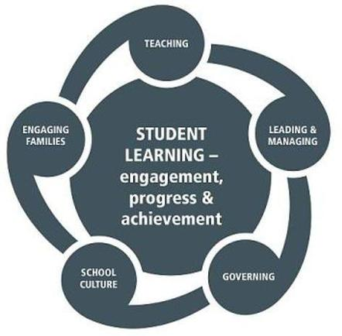

PB4L
Taihape Area School is a PB4L (Positive Behaviour for Learning) School. “Our mission is to improve academic outcomes and promote positive behaviours through a supportive environment.”

At Taihape Area School there are a set of school wide expectations which apply across the school in every circumstance and setting.
- We show Rangatiratanga – We are Learners
- We show Manaakitanga – We are Respectful
- We show Whanaungatanga – We are Caring
- We show Wairuatanga – We are Reflective

From these, a set of expectations for behaviour has been developed for each setting: All Settings, Learning spaces, Active Supervision Spaces and Off Campus Spaces. These are our expectations for behaviour in our school.

At Taihape Area School it is important to us that there are high expectations of behaviour and academic outcomes, and that we recognise, value and develop each student as a total and unique person.

PB4L School wide means that the above expectations apply to all members of our school community and those connected to us.
It is particularly important that staff model these expectations at all times.

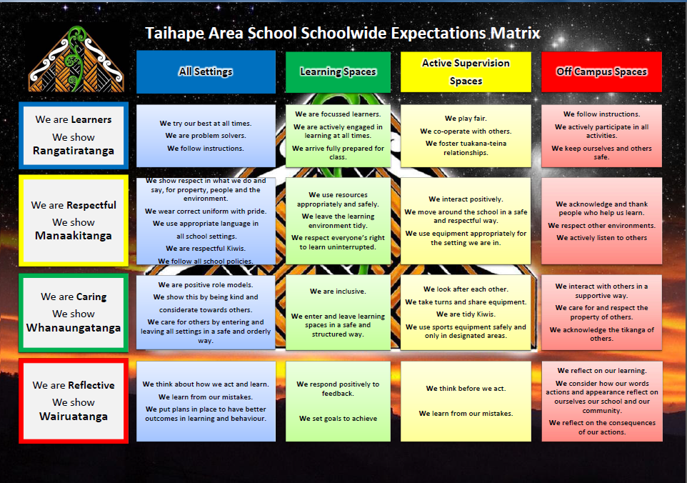
MOKAI PATEA CURRICULUM
The Board of Trustees has a Community Goal to enhance the partnership between the School, whanau, families, and the wider community. Over a period of many years the Iwi of Mokai Patea have developed an Education Strategy.

The vision of this strategy is “Mokai Patea enjoying educational success as Mokai Patea” through his/her (the learners) language, culture, and identity.

We would like to acknowledge whanau who have contributed to the development of the School Values – Rangatiratanga, Whanaungatanga, Wairuatanga, and Manaakitanga.

These values are encompassed within the School, and the Mokai Patea Education Strategy, to create a strong Mokai Patea Learner.

OPEN DOOR POLICY
At Taihape Area School we operate a genuine open door policy. Parents are encouraged to keep in contact with the Class Teacher, or Year Deans, to discuss any issues regarding the education of their children. Early intervention, and prompt action, can prevent small problems from becoming major issues.

Absence
Please advise us of your child’s intended absence either by phone, text, email or message through another child. The Office Manager (Cathy) will follow up on unexplained absences, but this is a time consuming exercise. No follow up note is required if we have been advised on the day of absence.

- PHONE: 3880130 before 8.50am
The answer phone is operational out of school hours
- email – cgregory@tas.school.nz

No child is permitted to leave the grounds during the day without permission.

CHANGE OF ADDRESS OR PHONE NUMBERS
Please notify us immediately if there is a change of parent/guardian, address, phone number, or emergency number.
In cases of sickness or accident, we need to contact parents immediately and this information is of vital importance.

ENROLMENT
An enrolment appointment, made at the office, enables the smooth coordination of your child’s first days at TAS. Cathy, our Office Manager, will set up a meeting with the appropriate Dean, or AP, and they will then ensure you have all the information you need about uniform, stationary lists, and fees, and take you on a tour of the school.
For the child’s first admission to a school it is necessary to provide the following:
- Birth Certificate – proof of age;
- Vaccination Certificate;
- Address and phone number;
- Alternative phone number of friend or relatives for emergencies only;
- If from overseas.

BOARD OF TRUSTEES
The Board of Trustees is responsible for the Governance of the School and meets monthly. Trustees are available to talk to you about any concerns you may have about the operation of the School, or any suggestions you may have. A list of current members accompanies this Booklet.

SCHOOL ORGANISATION
The school follows the primary and secondary curriculum as set down for State Schools.
Students in the Junior School, are classified as Years 1 to 8
Students in the Senior School are classified as Years 9 to 13

CLASS STATIONERY
You are encouraged to purchase stationery requirements before your child starts school. Specific stationery lists for each year level are available from the school office.

SCHOOL DONATION
This donation is paid annually and helps to fund resources and activities not provided by the Ministry of Education. We usually expect this donation to be paid at the start of the school year. However, if you have any difficulty paying these, please contact the Principal, or the Office, to make alternative arrangements. These are set on a $50.00 per student basis: however, the maximum any family will pay is $120.00 per family of 3 or more students.

This donation helps to pay for the resources and activities not fully funded by the Ministry: Computers/musical instruments/student council/school van/sports travel/sports gear/house activities/school exchanges/prizegiving/cultural exchanges/activities contributions to travel/contributions to visiting performers/contributions to junior school activities.

PRACTICAL COURSE COSTS YEARS 7-13

Courses such as technology, food and nutrition, art, outdoor education and computer studies do have individual course costs which must be paid. These fees are not part of the school donation. Invoices for these courses will be sent home each term for courses selected. There will be no practical course costs for Year 1-6 as these will come out of the school donation.

HEALTH
Good health is essential for school progress, and in partnership with parents, we address any health issues. Public Health Nurse (Narisa Sargison) is available for students to see each Monday (from 9.30am), and students need to make an appointment with the office.

A Dentist checks students teeth at least twice a year. Please contact the Taihape Clinic if a problem arises (Phone 063882016). Students must sign out from school. Years 1-6 are escorted to and from the clinic, by the Dental Hygienist. Older students travel to the clinic in pairs.

Common Health Ailments
- Hearing and Vision tests are carried out in the first year of school and parents can request further checks when thought advisable. The tester visits us once a term.
- Immunisation protects! Five-year-olds entering school are expected to have their immunisation programme up to date. Please check with your family doctor of Public Health Nurse to ensure this is done. Immunisation programmes are also in place for Year 7 & 8 students.
- Headlice or Pediculosis. Despite all precautions, these nuisances do make an occasional visit. The only evidence of infestation are live headlice. By far the best method of control is to carefully inspect your child’s hair at least once a week when washing – if in doubt ring the Public Health Nurse Narisa Sargison, or see a Chemist. Lice can be controlled quite readily. Regular combing can also help to eradicate live lice. A note will be sent home to the entire class if head lice are identified in a Junior Class.
- Common Ailments – period of exclusion from school:
Chicken Pox - for one week from the appearance of rash,
Measles - for one week from appearance of rash,
Mumps - until swelling has completely subsided,
Ringworm - must be under treatment
Impetigo - (school sores) must be treated and covered

SPORTS, CAMPS AND OTHER EXTRA CURRICULA ACTIVITIES
All students have the opportunity for sports instruction throughout the year. The T.A.S. Physical Education Uniform is available from the School Office. A note from home is required if a student is to be excused from physical activities.

We have a wide range of sports equipment available for the student’s use at interval and lunchtime. Hockey on the turf and basketball in the gym are favourites for students and teachers.
The school encourages all students to participate in a range of organised sports. As a school we field teams in netball, hockey, rugby (boys and girls), volleyball, touch rugby, senior football, cricket, and basketball. Saturday competition in Junior Rugby is organised by the local Taihape Rugby Club.

Sport is an important part of our school culture, and we strongly advocate the involvement of our students in a wide range of activities.

School Camps are organised at the beginning of the year. Each year level has EOTC (Education Outside the Classroom) activities organised to cater to the needs of the students involved.

All extra curricula activities incur a fee. This is discussed prior to the start of the course/activity and specific information can be found in our fees document or in information from the teachers in charge of activities and events.

OPTIONS PROGRAMME – Year 7-13
When the students reach Year 7, they are able to participate in the ‘Options’ programme. This programme provides an opportunity for students to develop skill in specific fields. Some options are developed over a whole day, all bringing realistic experiences and learning which are linked to the New Zealand Curriculum Learning Area’s with explicit outcomes for students to attain.

The Key Competencies of the Curriculum – thinking, self-management, participating and contributing, relating to others, and using symbols, text and language – are all inclusive in the option programme.

Options activities include rafting, skiing, agriculture, art, hard materials, food technology, EOTC, and Sport.

SWIMMING
During the 1st and 4th terms, the teaching of swimming is taken in the Taihape Heated Pool. This is part of the normal Year 1-8 school Health and PE programme, and we expect all students to take part. They need to bring named togs and towels in a swimming bag or plastic bag.

ROAD SAFETY
A Road Patrol operates in front of the School. This is a Year 6-8 responsibility.

Cyclists must wear a helmet

PARENTS SHOULD SET AN EXAMPLE BY USING APPROPRIATE ROAD RULES THEMSLEVES

NEWSLETTERS
Parents are kept informed through weekly newsletter of school events. The newsletter is given to each child on Mondays, or if you prefer emailed home. It can also be accessed on the School Website

http://www.tas.school.nz

PROMOTION THROUGH THE SCHOOL
Most children require at least two-years in the Years 1-2. The actual period can vary according to birthdates.
Then Children spend one year in each level for Years 3-8. We often have composite classes (classes made up of different year levels). If such a situation arises, where your child needs to move into a different classes during the year, it is School Policy to consult with the parents before any decision is made.

SCHOOL HOURS
Bell Times:
The day begins at 8.45am and finishes at 2.45pm.
Interval is from 10.30-10.55am
Lunch break is 12.30 – 1.10pm.

The School Day is divided into three 90 minutes blocks.

It is important that students go straight home after school, and do not detour without parents’ knowledge. It would be wise to warn your children of the dangers of loitering or accepting rides from strangers on the way to and from school.

Whole School hui-ata-a (Get Together) is held on Monday Morning in the Hub. This is for karakia, waiata and notices. The Junior School have hui-ata-a each morning in Learning Street.

PARENT HELPERS
We encourage parents to assist in non-teaching activities in the classroom. As well parents often provide assistance with sport, school camps, transportation, and Kapa Haka.

If you feel you would like to help please contact the office – Phone 06 3880130, or tell a teacher.

REPORTING TO PARENTS
Three times a Year whanau are invited to share in learning celebrations. Children take a lead role in these events, goals are set and reflected upon.
Parents are always welcome to contact the School for an appointment with the Class Teacher, however there are 3 occasions during the Year when the school reports to parents: -

Term 1 Junior School - Goal Setting Conferences (Whanau /Student/Teacher
Interviews)
Senior School – Goal Setting Conferences
Term 2 Junior School - Learning Celebrations (Whanau/Student/Teacher Interviews)
Senior School- KAMAR Report
Term 3 Junior School – Whanau Engagement
Senior School – Learning Conferences
Term 4 Junior School - Learning Celebrations and Written Reports
Senior School- KAMAR Report

LUNCHES
- Lunches can be purchased from ‘The Canteen’. These often include meals such as macaroni and pizza bread;
- No Year 0-11 Students my go to town to purchase lunches. Year 12 have a set day, while the freedom to go to town is a right of passage for Year 13 Students.

DIGITAL DEVICES
Children are encouraged to bring digital devices, including laptops and iPads, to school, and have free internet access.

However at times they may be asked to refrain from using them during classes. Devices may be confiscated if used inappropriately.

N.B. Students will be encouraged to use digital devices responsibly, and look after them carefully, but the School accepts no responsibility for the physical upkeep of these devices, and they are brought to school at the owners own risk.

TRANSPORT
On enrolment all students must sign a bus passenger’s agreement. This ensures the safe travel of all TAS students, who travel regularly, or on School Trips.

LIBRARY BOOKS AND HOME READERS
Your child will bring home library books from school. We spend a significant amount on these books and we would ask your assistance in looking after them.
The Junior School in particular bring many reading books home. These are to support the school reading programme and are usually books that the children have already read at school, but some are for shared reading with parents.
We ask you to let your child share their sense of accomplishment with you.
A parent’s encouragement can work wonders!!

N.B. Please ensure your child returns the home reading books each day.

CLOTHING
We have our own Uniform available from the Warehouse in Palmerston North. Uniform protocols and standards are set by a Uniform Committee, and we have worked to ensure our uniform is suitable for all levels of the school. As a School we are focused to ensure all children maintain a tidy standard of dress, and wear their uniform with pride.

Please name all clothing and shoes, and in the Swimming Season underclothing as well. We can only trace owners of lost property items when they are named. We do ask that clothes be adequate, clean and tidy, and appropriate for school activities.

SCHOOL AWARDS AND ACKNOWLEDGEMENTS
It is our policy to acknowledge success at School through awards, certificates, a sharing time at School Celebration Assemblies, and the School Newsletter (e.g. Tall Poppies).

Awards are made to acknowledge academic achievement in the classroom, sporting prowess, cooperative and social skills, and special occasions.

HOMEWORK
Home and School Partnership
Homework needs to have a clear purpose and relevance to the student’s development and should enhance the whanau/student/home/school partnership rather than strain it.
Purpose
- Engage whanau, teachers and students in a negotiated partnership to achieve the following:
- To reinforce/enhance/revise in class learning
- To develop independent lifelong learning
- Access to different learning opportunities
Nature
Homework should be set in a variety of ways that could involve individual student work or whanau cooperation, for example:
- Written – question and answer, notes
- Oral – interview, spelling
- Physical gathering – magazine clippings, pictures
- Reading - short stories, internet sites
Homework should be set mindful of the time required to achieve a satisfactory result.
Expectation
That teachers, whanau and students will fulfill their part of the partnership.
- Teachers should set appropriate homework and incorporate it into the student’s learning and liaise with parents.
- Students complete homework to the best of their ability.
- Whanau support student’s efforts and liaise with teachers.
Individual teachers at TAS will inform students and whanau of the nature and structure of ‘leading me to lead my learning’ homework.

Homework is viewed as an extension of school activities, and a means of reinforcing learning, and developing and practicing independent study skills. It should be a positive experience for parent and student, and is not always compulsory.

Guidelines:
Students in junior classes will bring home reading material most nights, and a log to record their reading shared at home.
Students in year 3 to 8 may use a homework communication book/notebook and teachers explain their expectation in letters to parents at the beginning of the school year.
Regular homework tasks include reading, spelling and maths basic facts. Homework involving topic and project work is spread over several days.
It is recommended that time allocated to homework be limited to 30 minutes per day, or 2 hours per week. We believe children should have the opportunity to take part in a range of after school activities.
Most of all homework should be an opportunity for families to share in the learning of their children and needs to be a positive and affirming experience.

SPECIAL EDUCATION PROGRAMMES
We are an inclusive school that caters for a range of students. The SENCO meets with teachers to coordinate programmes for children identified as having learning difficulties in various areas. Support is provided for children requiring additional assistance, as well as those requiring extension.
Support Programmes include: -
- Reading Recovery;
- RTLit (Resource Teacher of Literacy);
- RLLB Resource Teacher of Learning and Behaviour).

ASSEMBLIES
Celebration Assemblies are held through-out the year, usually once per term. These are very important occasions when we come together as a School to celebrate Whole School, Class, and individual successes and achievements. Each house has turns hosting the Assemblies, which are run by the pupils themselves. Parents and community members are encouraged to attend.

IS YOUR CHILD READY FOR THE JUNIOR SCHOOL?
Does your child:
- Know their own name, address and telephone number well enough to repeat when necessary?
- Know the safest way to school and be aware of road safety?
- Put away play things after using them?
- Take off and put on outer clothing without assistance?
- Tie their own shoes?
- Know how to use a handkerchief and always have one?
- Know how to wash hands after using the toilet?
WHANAU: As parents what can you do to help?
- Talk to them about starting school.
LABEL CLEARLY all possessions that your child will bring to school. It is not wise to send good toys to school. All lost property (and we do acquire quite a lot), is kept in the Cathy’s Office, and is always available for parent’s inspection.

HOW TO SUPPORT YOUR CHILD’S LEARNING (Junior)
Send them to school on time each and every day.
Encourage them to bring their work home.
Hang up a picture or painting for a few days – be proud of it!
Give them duties around the house, which require one or two simple directions. This will add to their confidence.

Select good stories and books to read to them daily.
Be selective with television programmes, and use of computers. Many television and computer programmes are great, but some are not suitable and may lead to inappropriate behaviour.

When reading or talking to them, make sure they are listening. We find many students who can talk, but not listen.

Keep in close contact with the teachers about their progress. The term 1, 2 and 4 learning celebrations are an excellent opportunity for this.

Make sure they get to bed at a reasonable hour. A 7.00pm bedtime is reasonable for a 5-year-old. We have students falling asleep because they watch TV until a late hour. For those messy art lessons, an old shirt is very useful to keep paint off clothes.

NCEA - WHAT CAN PARENTS DO TO HELP? (Year 11-13)
How can you as parent’s help your people succeed at School? Talk often about how school is going, what is happening in the classroom: -
- Discuss their goals for the Year, for the next 3-5Years, and potential pathways for life post school;
- Be a coach on Time Management. Avoid making it a battle. Gently remind them of their longer term goals;
- PART TIME WORK: Watch the amount of hours. It is a balance. Research has shown that 10-12hours per week can enhance NCEA performance. More than this can be detrimental. Reduce the hours around exams and revision time;
- SOCIAL LIFE: Again work out a balance. Perhaps as a reward for completion of tasks;
- Find out when they work best on their study, morning, afternoon, or evening;
- Create a good space to learn. A desk, good-light, comfortable chair, quiet;
- Music: Appropriate for the task;
- Revision for externals should mirror the exam situation – quiet;
- Breaks every 40-50 minutes;
- Practice exams for external assessments are on the NZQA website: www.nzqa.govt.nz; Practice tasks for internal assessments at: www.tki.org.nz.

WEBSITE
The School website can be accessed at http://www.tas.school.nz
The Website provides an in-depth insight into the operation of Taihape Area School.
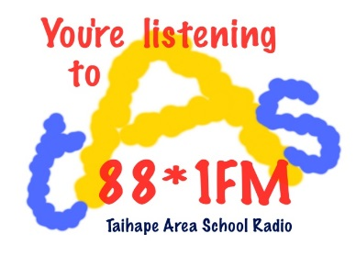
TAS RADIO
The School has a Radio Station (TAS 88.1 FM) that operates 24/7.

AND FINALLY…
Please remember, we have your child’s best educational experience at the heart of all we do. We passionately believe that ‘Together Each Achieves More” (TEAM).
